EXE file association problem (Windows XP)
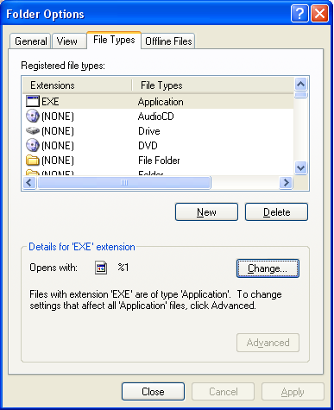
In Windows Explorer, Tools\Folder Options…\File Types gives a list of file associations. But you can’t normally see an entry for EXE in the list.

To see one,
- click New
- enter EXE in the File Extension box
- click Advanced
- wait – “Application” should appear in the Associated File Type box
- click OK
Now you can! See right.

Look in the lower panel (“Details for ‘EXE’ extension”).
If it looks like this, all should be well.
(Note that the “Advanced” button is greyed out – not available in this context.)

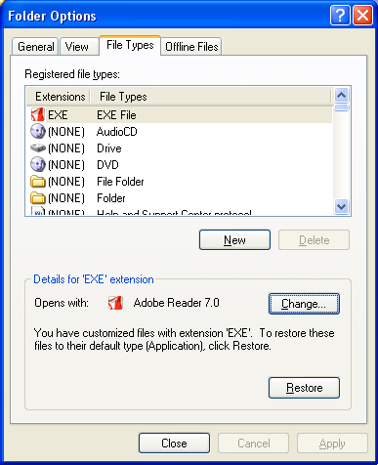
If you Close this window and reopen it, the EXE association will have disappeared from view. You can make it reappear by repeating the bulleted steps above.

If however there is some problem with the EXE association, then it might look something like this (after you have repeated the bulleted steps above to make the entry for EXE visible):
In this situation, trying to run an EXE will result in launching Adobe Reader 7.0 instead, and this will then give some failure message because it doesn’t understand the format of the .exe file it has tried to open.

If you’re lucky, as in this case, the greyed-out Advanced button will have been replaced by an active Restore button.
Click the Restore button to return to normality!

If the Restore button isn’t there – tough!

DJKR 31 Aug 06

Postscript – 3 Sep 06
It appears that you can achieve the same effect by a registry edit, below. If you don’t know how to do this, or you don’t know the perils of editing the registry, then don’t even try it!
Windows Registry Editor Version 5.00

[HKEY_CURRENT_USER\Software\Microsoft\Windows\CurrentVersion\Explorer\FileExts\.EXE]
"Application"=""

